# C291 – System Programming in C and UNIX

## Assignment 5

### Task:

Write a C program to create and manipulate singly linked list.

What is a linked list?

Linked lists are a way to store data with structures so that the programmer can automatically create a new place to store data whenever necessary. One way to visualize a linked list is as though it were a train. The programmer always stores the first node of the list in a pointer he won't lose access to. This would be the engine of the train. The pointer itself is the connector between cars of the train. Every time the train adds a car, it uses the connectors to add a new car. This is like a programmer using malloc to create a pointer to a new struct.

Data

Pointer

Data

Pointer

Data

Pointer

NULL

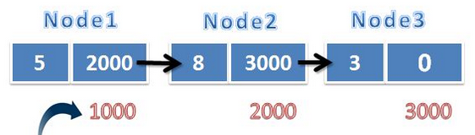

Each element is a node in linked list. Elements is going to be a struct. Elements has two data members, data and pointer. Data will hold a value, in this assignment integer value and pointer will hold value to address of next element. The last element in linked list will have NULL pointer.

Create a linked list program using which user can add elements, insert elements and search a number in the linked list.

**Note:** You are required to have node definitions in a different file, operations in another file and a separate file to interact with the user.

**Sample Output:**

Enter your option:

1. Add element
2. Search
3. Insert
4. display
5. Exit

1

Enter the value: 30

Value added to the linked list

Enter your option:

1. Add element
2. Search
3. Insert
4. display
5. Exit

1

Enter the value: 40

Value added to the linked list

Enter your option:

1. Add element
2. Search
3. Insert
4. display
5. Exit

4

30->40

Enter the position

1

Enter your option:

1. Add element
2. Search
3. Insert
4. display
5. Exit

3

Enter the position

1

Enter the value

50

Element inserted

30->50->40

Enter your option:

1. Add element
2. Search
3. Display
4. Exit

4

Exiting…

**NOTE: You are required to code only in open terminal. You should not use any IDE.**

Due Date:

The submission is due on Wed 06/15/2016 11:59 PM

What to turn in:

Commit your changes to your github repository. We’ll grade whatever version you’ve put there at 11:59PM on the due date.

Academic Integrity:

You may discuss the assignment with other people at a high level, e.g. discussing general strategies to solve the problem. You may also consult printed and/or online references, including books, tutorials, etc., but you must cite these materials in report. However, if you are submitting the code, then it must be your own work, which you personally designed and wrote. You may not share written code with any other students, nor may you possess code written by another student either in whole or in part, regardless of format. The professor and AI’s are always available to help, so reach out through canvas if you need one!

### Rubric:

* You will get 50% of total marks on successful compilation of program without any errors
* You will get 70% of total marks on successful execution of program
* You will get 90% of total marks on passing all test cases
* You will get 100% of total marks based on your code clarity
* The following falls under clean code
  + Proper names for variables.
  + Follow camel case patterns.
  + Comment where ever needed
  + Check for valid inputs & valid range
  + Output unambiguous & user friendly messages